Grazioso Salvare Search and Rescue Dashboard
Developer: Ronnie Corpuz
Course: CS 340
Project Overview
This project delivers a full stack MongoDB dashboard for Grazioso Salvare. The application allows users to filter and analyze shelter dogs suitable for specialized rescue training. The system follows the MVC design pattern:

Model: MongoDB database
Controller: Python CRUD module and Dash callbacks
View: Dash web dashboard interface
The dashboard dynamically filters, displays, and maps shelter animal data.
Required Functionality
The dashboard provides the following features:
• Unfiltered interactive data table of Austin Animal Center Outcomes data
• Interactive filtering options for:
- All Dogs
- Water Rescue
- Mountain/Wilderness Rescue
- Disaster/Tracking
- Data table updates based on selected filter
- Breed distribution chart that updates dynamically
- Interactive geolocation map that updates based on selected row
- Reset option that returns to full dataset
- Grazioso Salvare logo and unique developer identifier displayed
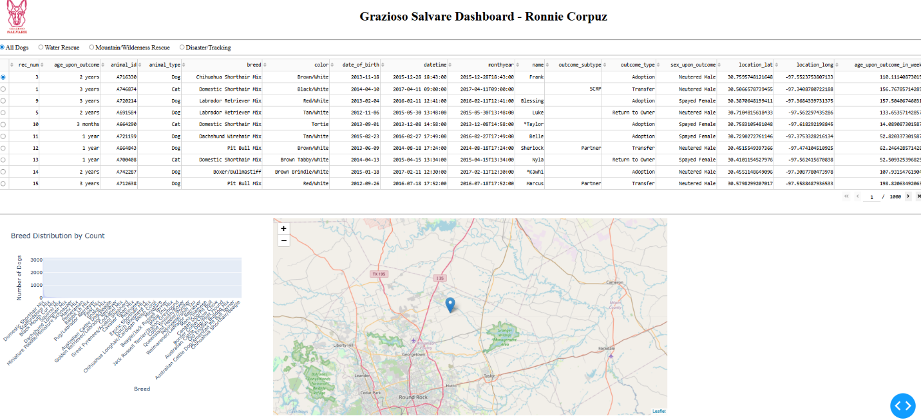Initial Dashboard State (All Dogs selected)
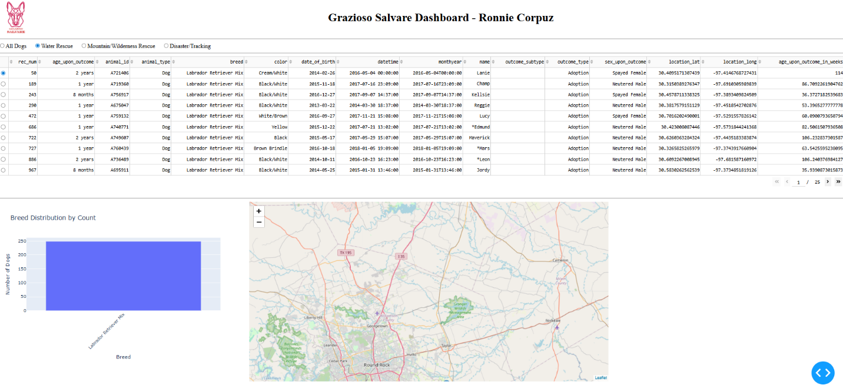Water Rescue filter applied
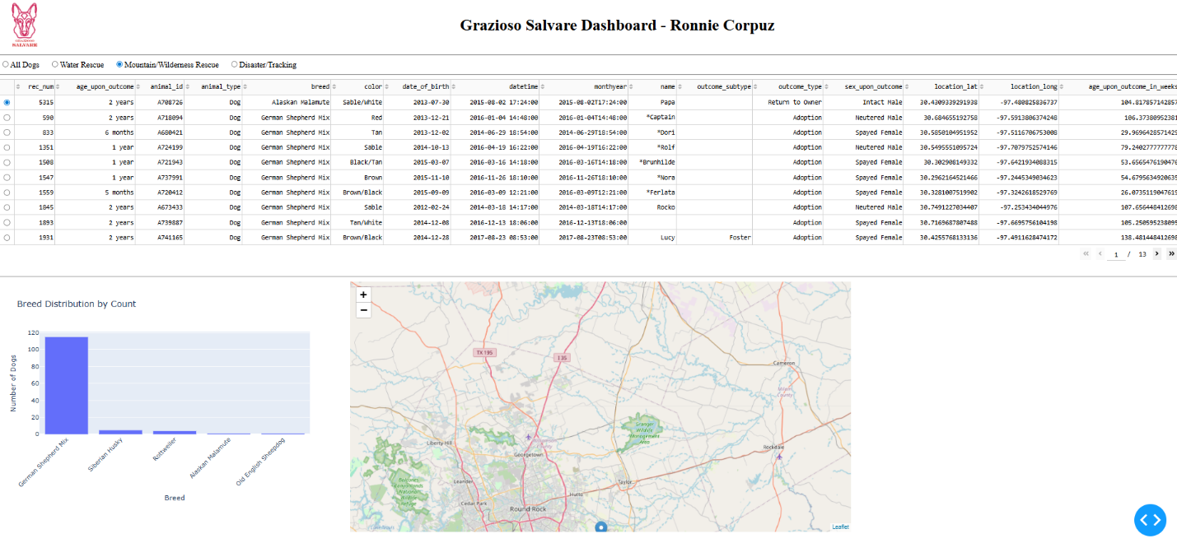Mountain/Wilderness Rescue filter applied
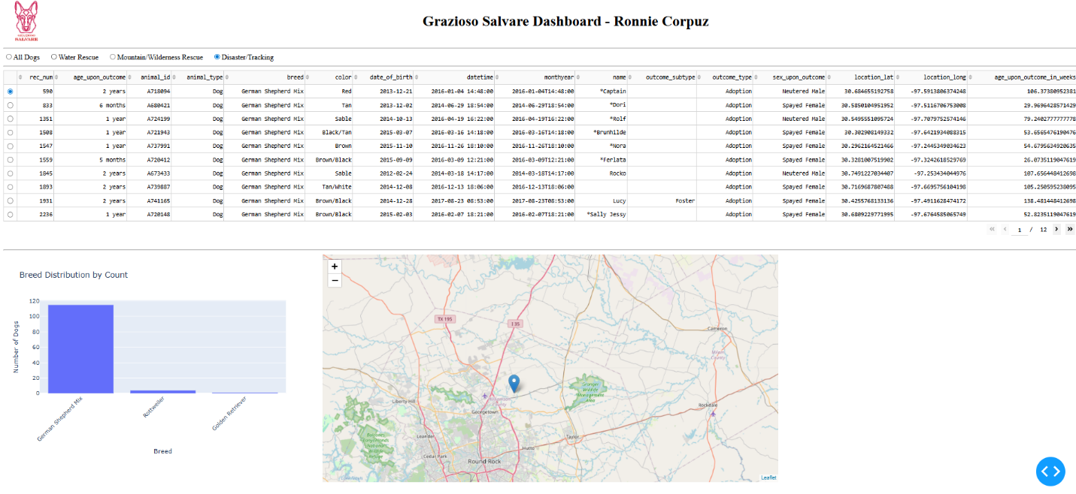Disaster/Tracking filter applied
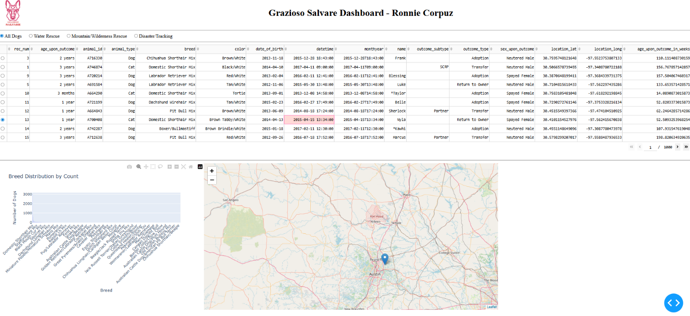Reset to All Dogs
Tools and Rationale
MongoDB
MongoDB was used as the model component because it stores data in JSON document format, which integrates naturally with Python dictionaries. Key advantages include:
• Flexible schema for semi structured shelter data
• Efficient querying using operators such as $in, $gte, and $lte
• Strong integration with Python via PyMongo
• Scalable document-based storage
Python and CRUD Module
A custom Python CRUD module was developed to handle database operations. This module allows secure and structured access to MongoDB and serves as the controller between the database and the dashboard.

Dash Framework
Dash was used to build the web application interface. Dash enables:
• Interactive components such as radio buttons and data tables
• Callback based dynamic updates
• Seamless integration with Plotly visualizations
• Full web application development in Python without JavaScript

Plotly Express
Used to generate the dynamic breed distribution bar chart based on filtered data.

Dash Leaflet
Used to create the interactive geolocation map displaying animal locations using latitude and longitude.

Development Process
- Built MongoDB database using Austin Animal Center dataset.
- Created and tested Python CRUD module in Project One.
- Developed unfiltered interactive data table.
- Implemented MongoDB queries for each rescue category.
- Added radio button controls to trigger filtering.
- Connected filtering logic to the data table through Dash callbacks.
- Implemented grouped breed distribution chart using value counts.
- Integrated geolocation map that updates based on selected table row.
- Added logo and developer identifier for branding compliance.
- Tested all filters and captured required screenshots.

Challenges and Solutions:
Callback Errors
Initial NoneType errors occurred when no selection was present. Defensive checks were added to prevent empty dataset crashes.
Chart Visualization
Initial chart plotted raw rows instead of grouped counts. This was corrected using value_counts() to display accurate breed totals.

Jupyter Dash Port Conflicts
Port conflicts occurred when rerunning the server. This was resolved by specifying an alternate port and restarting the kernel when necessary.

Reproduction Instructions
To reproduce this project:
- Install MongoDB locally or use the Codio environment.
- Import the Austin Animal Center Outcomes dataset into MongoDB.
- Place the following files in the same directory:
  - ProjectTwoDashboard.ipynb
  - CRUD_Python_Module.py
  - Grazioso Salvare Logo.png
- Install required Python packages:
  - dash
  - jupyter_dash
  - dash_leaflet
  - plotly
  - pandas
  - pymongo
- Open ProjectTwoDashboard.ipynb in Jupyter Lab.
- Update MongoDB credentials if needed.
- Run all cells.
- Use radio buttons to test each rescue filter.

Resources Used
MongoDB Documentation
https://www.mongodb.com/docs/
Dash Documentation
https://dash.plotly.com/
Plotly Express Documentation
https://plotly.com/python/
Dash Leaflet Documentation
https://dash-leaflet.herokuapp.com/
Austin Animal Center Data Portal
https://data.austintexas.gov/
Project Summary
This project successfully implements a full stack MVC dashboard that enables Grazioso Salvare to identify rescue candidate dogs through dynamic filtering, visualization, and geographic mapping. The architecture ensures maintainability, scalability, and open-source adaptability.

